Comparative Economics: Global Risk and European Responses
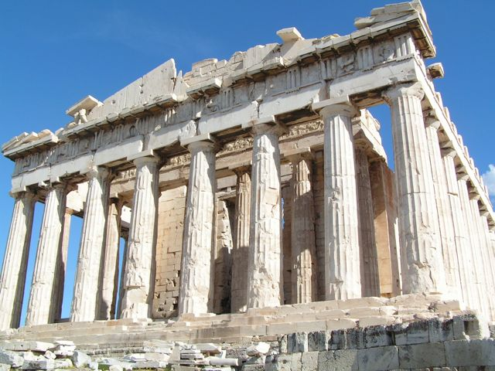

Semester & Location: | Spring 2020 - DIS Stockholm
Type & Credits: | Core Course - 3 credits
Core Course Study Tours: | Kiruna, Sweden; Athens, Greece
Major Disciplines: | Economics, Finance, and Political Science
Faculty Members: | Jim Breen
Program Director: | Susanne Goul Hovmand - sgh@dis.dk
Time & Place: | Mondays and Thursdays 14:50 - 16:10  Room: 1D-410
Description of Course
Markets generate wealth, but there are no guarantees of how. On the international stage, the volatility of markets contributes to many of the key global challenges of our time: climate change, widening inequality, unprecedented waves of migration, financial crises, and increasing unemployment in the wake of digitalisation, automation, and A.I. In this course, we consider how responses to these challenges differ between Europe and the U.S., with a focus on the nature and extent of public interventions in the marketplace.
Prerequisite: One course in intermediate or advanced microeconomics at university level
Learning Objectives
By the end of this course you will:
- Be able to apply microeconomic tools to the analysis of a number of issues such as climate change and migration.
- Understand where markets work and where they don’t, with a special look at financial crises and the various approaches to their remediation
- Be aware of the economic impacts of A.I. and automation, and different approaches proposed to combat any negative implications.
- Be conversant with the tools governments use in their attempts to enhance economic growth at a regional and sub-regional level.
- Decide if economic inequality affects economic growth and wealth creation.
- Be conversant with economic theories on the concepts of public goods and externalities.
- Better understand current discussions relating to government deficits in both the US and Europe.

Faculty
The lecturer has been a professional economist working with the UN, governments, private companies, and social organisations for a number of years across Europe and Africa. He completed his undergraduate studies at the University of California (Santa Cruz and Berkeley) and his postgraduate work at the London School of Economics.

Readings and Other Media on Canvas:
Anechiarico, F. et al. (2017) ”Swedish Nursing Home Scandal 2011” in Legal but Corrupt: A New Perspective on Public Ethics. London: Lexington Books. pages 36 - 43
Dahlgren, G. (2014) Why Public Health Service? International Journal of Health Services, Volume 44, Number 3. pages 507–524
Goodman, J. and Loveman, G. (Nov – Dec 1991) “Does Privatization Serve the Public Interest?” Harvard Business Review
Jonning, L. (2009). "The Swedish Model for Resolving the Banking Crisis of 1991-93: Seven reasons why it was successful." European Commission, Directorate General for Economic and Financial Affairs Economic Paper 360
Roberts, D. (2012, September 24) ”Discount rates: A boring thing you should know about (with otters!)”. Grist
Rubin, R and Hughes, S. (2017, December 2) Senate Passes Sweeping Revision of U.S. Tax Code. Wall Street Journal
Taylor, J. (2006) Nordhaus vs. Stern. Cato Institute. Cato at Liberty.

Field Studies…
... will bring the students in contact with experienced users of econometric tools e.g. in think tanks or consulting firms.

Approach to Teaching
The teaching approach is to use established economic thinking and approaches to examine day to day issues that affect and will continue to affect you. A significant aim of this course is to leave you with a template for problem solving, applicable to many aspects of modern day living.

Expectations of the Students
Students will be expected to actively participate in ‘telling stories’ of how the theoretical models are expected to play out in real life. Each will support and enhance the learning of their fellows in class. Students shall come prepared with their own views and opinions to each session, and at times will be required to work in groups. Each student will be responsible for a presentation to the class.
Active engagement in classroom discussion is a key prerequisite to a good grade in this course.

Note on Attendance:
Class participation is a key aspect of our learning process. As such, any (and each) absence will result in a reduction of your class participation grade by 7.5%. If you have an ongoing medical issue resulting in more than one absence, please speak with your instructor.

Note on Use of Electronic Devices in the Classroom:
Aside from exams, which are in Canvas and must be completed on laptops, computers will only occasionally be used. The use of other electronic devices such as mobile phones is prohibited. Students found using electronic devices for purposes other than intended for the class will receive an “F” for their participation grade. There are 168 hours in any given week: this course will take up only 2.5 of them in class time.
Evaluation
In this class you will be evaluated on how well you can assimilate the tools and ideas presented and then use them to interpret the world around us. To that end it will be essential for you to learn material prior to class. This will enable us to use as much classroom time as possible, not for the acquisition of theory, but rather for using ideas and concepts to analyse and understand contemporary issues.
As part of that process, there will generally be quizzes set prior to class.

Components of the Course Grade

1. Class participation  This component covers active participation in class, performance in small assignments, feedback and questions on fellow students’ presentations (see #3 and #5 below). Participation is not to be confused with mere attendance during the semester. | 20%
2. Pre-class Quizzes  Most classes will be preceded by a quiz covering the assigned reading/viewing/listening. The quizzes are published on Canvas with their due dates and times. | 20%
3. Pre core course week and/or study tour presentations  Students will make presentations on organizations and or places we will visit. The purpose of the presentation is to prepare your colleagues for the visit as well as to provide some insight into the types of things we should consider or ask about while there. | 10%
4. Midterm Examination  There will be a midterm exam with questions on the lectures, student presentations, videos, and readings from the first half of the term. Any material covered in prior to the test is fair game for the exam. It is a closed-book exam that will last 1 hour. | 15%
5. Policy Presentation  Students will make an individual, 5 minute presentation on a project or policy they would like to implement in either Sweden or the US. The presentation will be followed by a 5 minute Q&A session. The presentation will outline the objectives of the policy, its underlying assumptions, and its theoretical underpinning as it relates to course material. | 15%
6. Final Examination  This exam is similar to the mid-term exam, but covers all material from the entire course. Any material covered in any lecture is fair game for the exam. It is a closed-book exam that will last 1 hour. | 20%

Academic Regulations
Please make sure to read the Academic Regulations on the DIS website. There you will find regulations on:
- Course Enrollment and Grading
- Attendance
- Coursework, Exams, and Final Grade Reports

DIS - Study Abroad in Scandinavia - www.DISabroad.org

